What the community told Council about disability inclusion
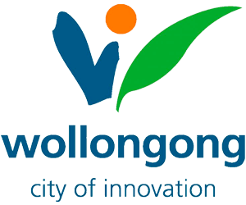 | Wollongong City Council is making a new plan for 2026 to 2030
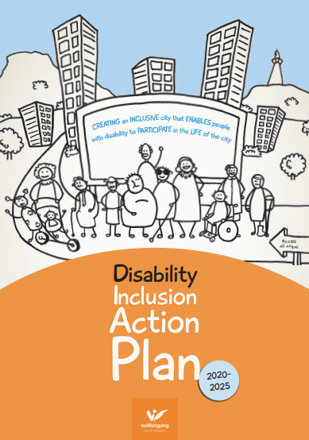 | The plan will help make services and places easier to use for people with disability
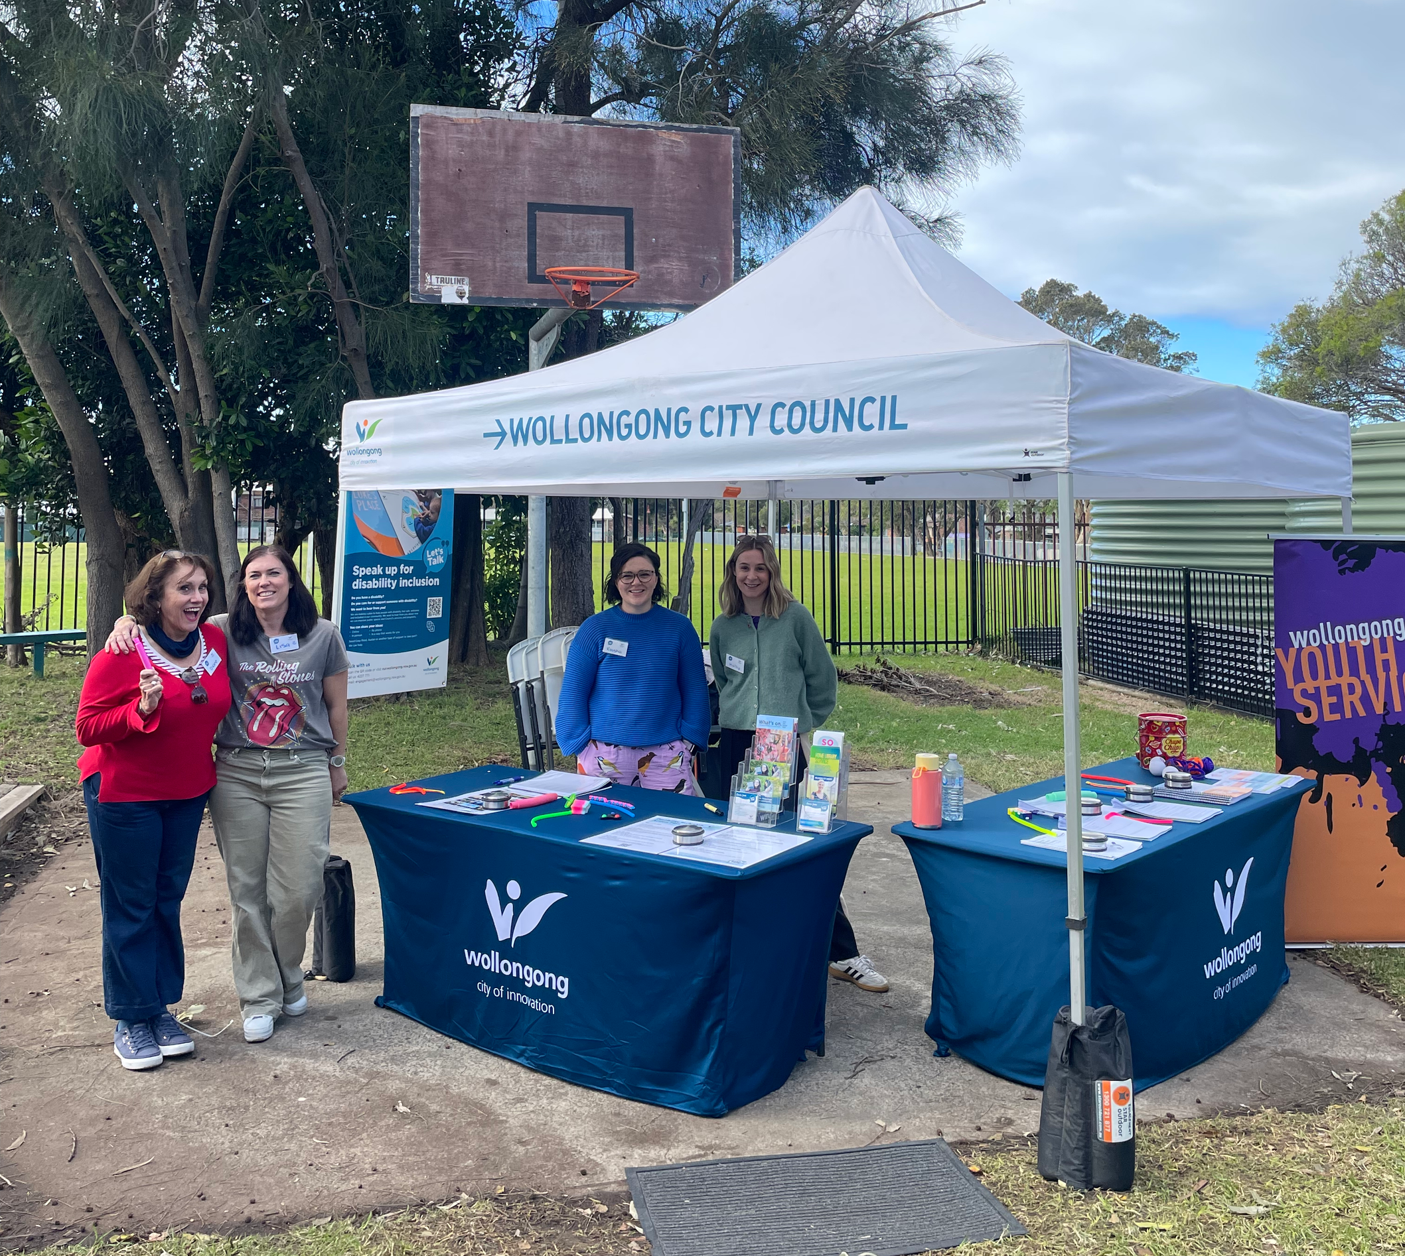 | We did lots of things to let people know we are making this plan  - Sent emails  - Met with people  - Held events and workshops
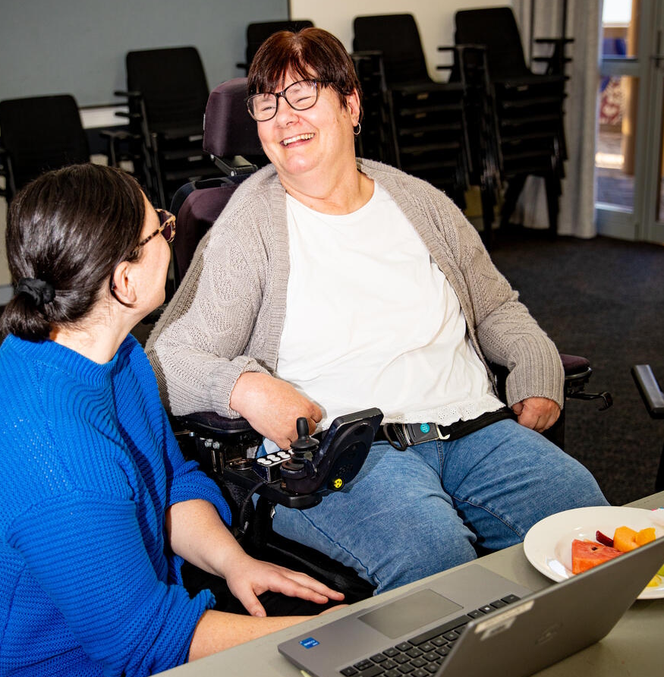 | We talked to  - People with disability  - Carers and families  - Support workers and services
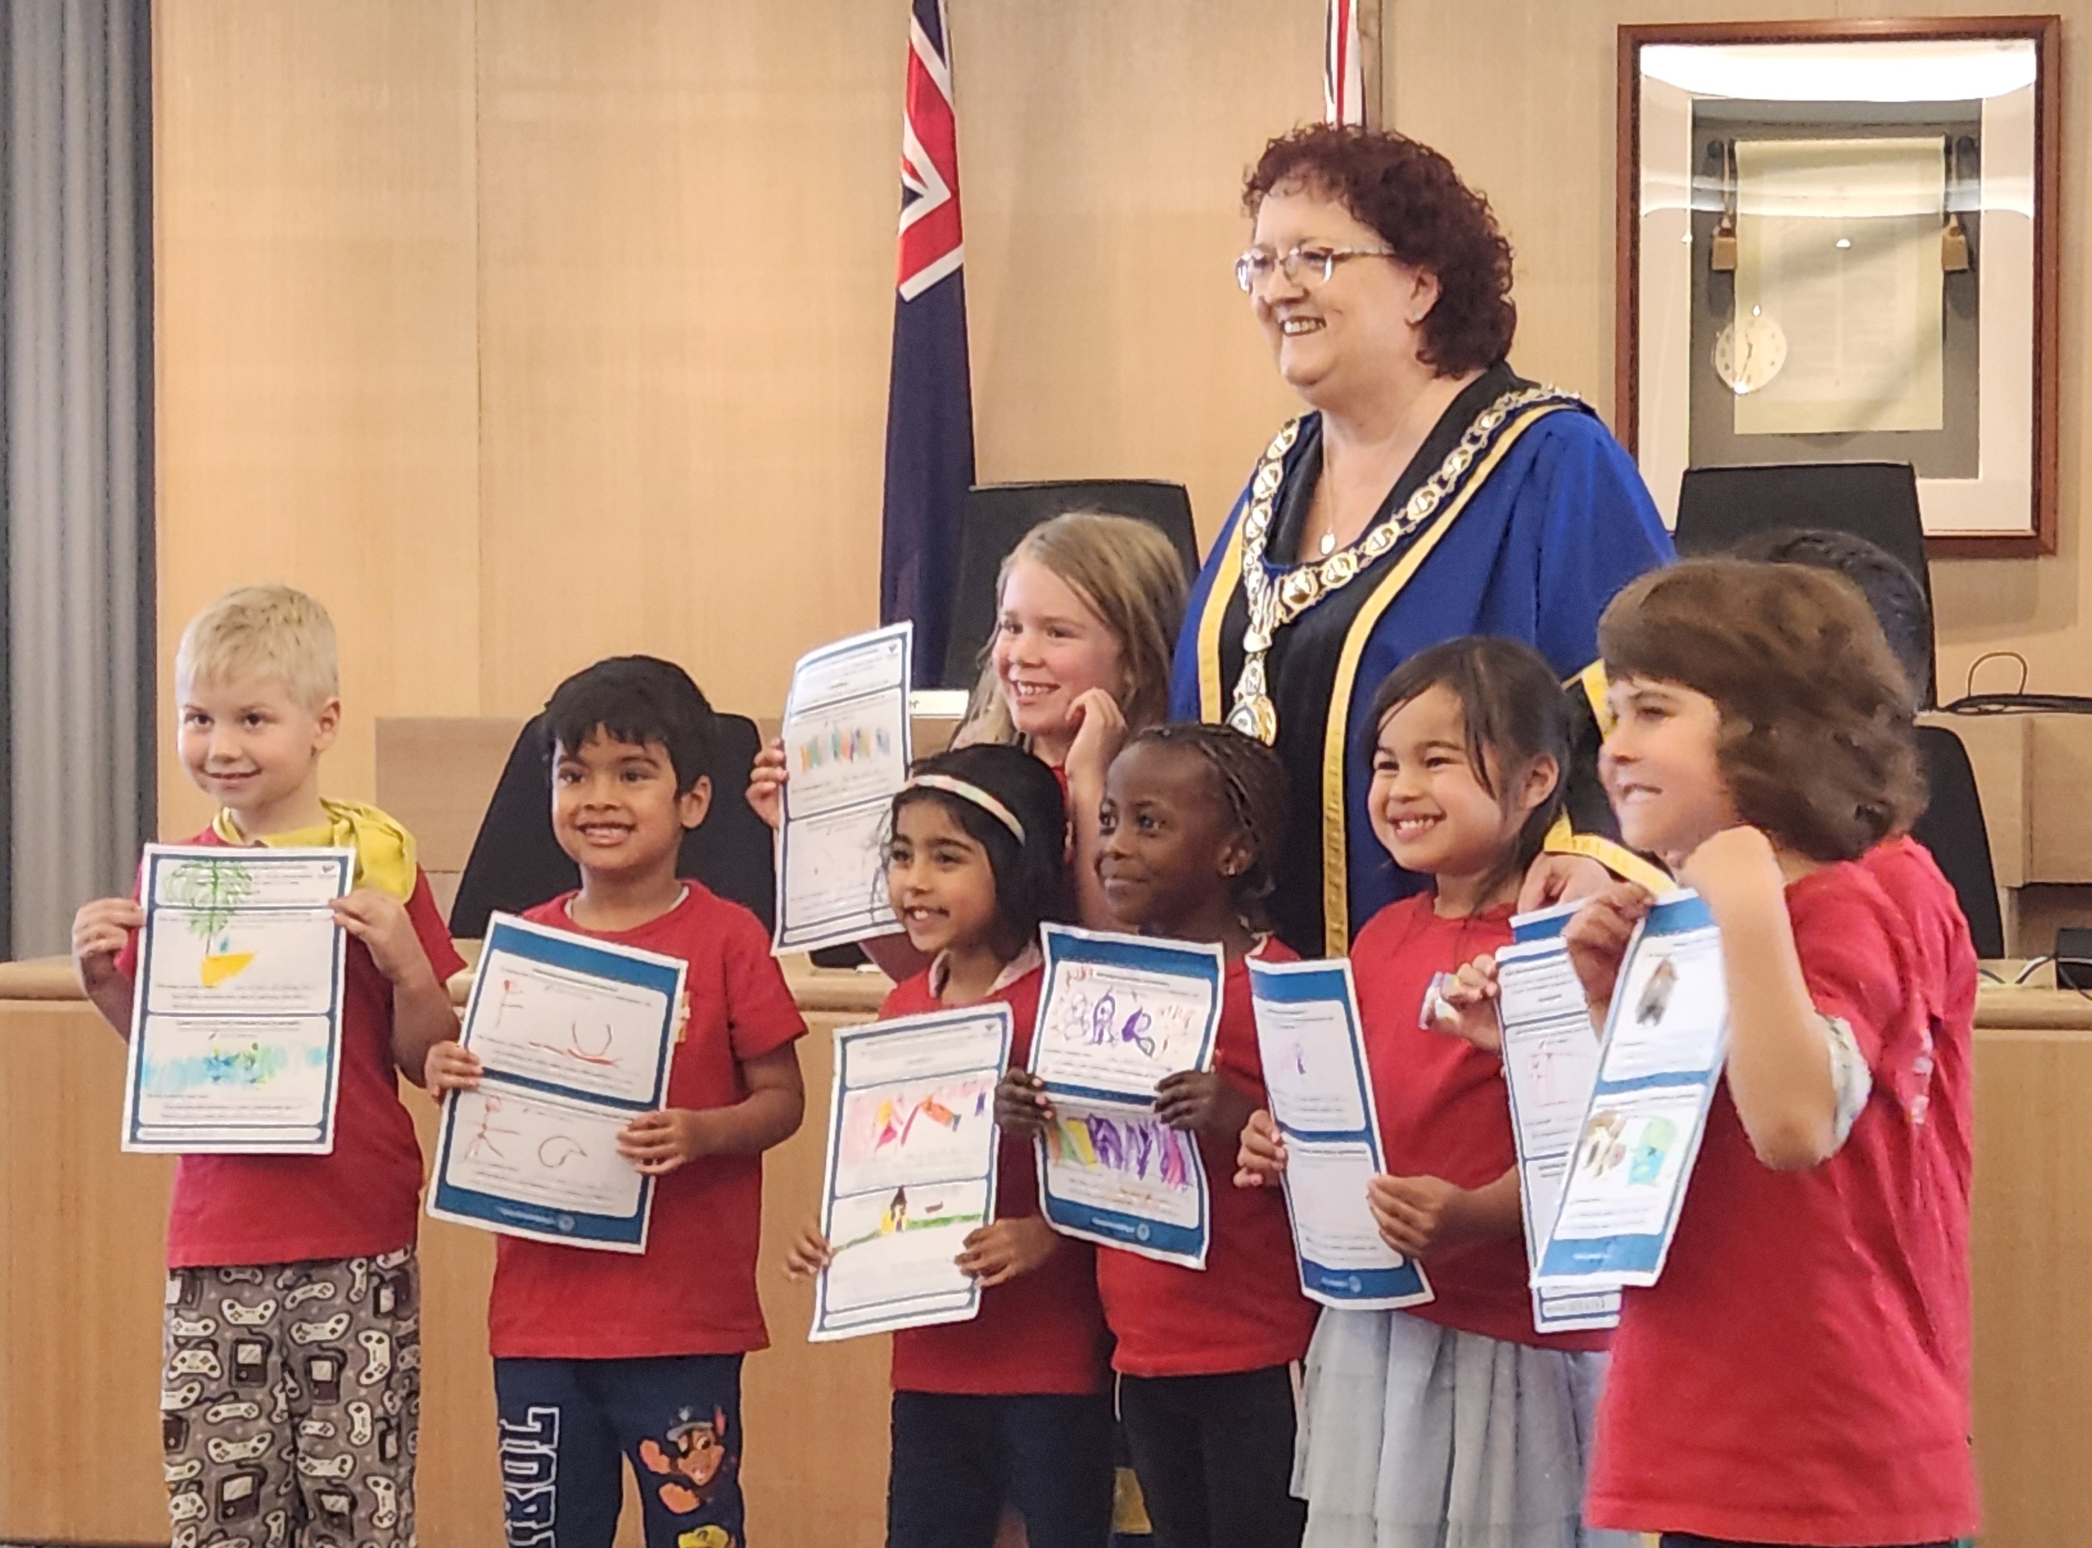 | We talked to people of all ages from different backgrounds
 | We asked them what should be in the plan
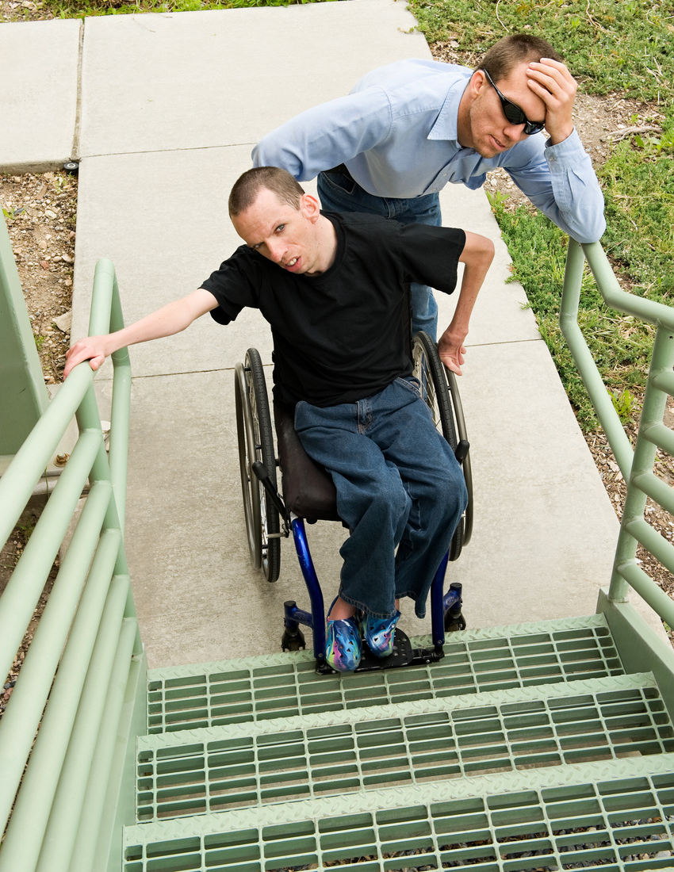 | They said it is hard for people to get to places and use buildings
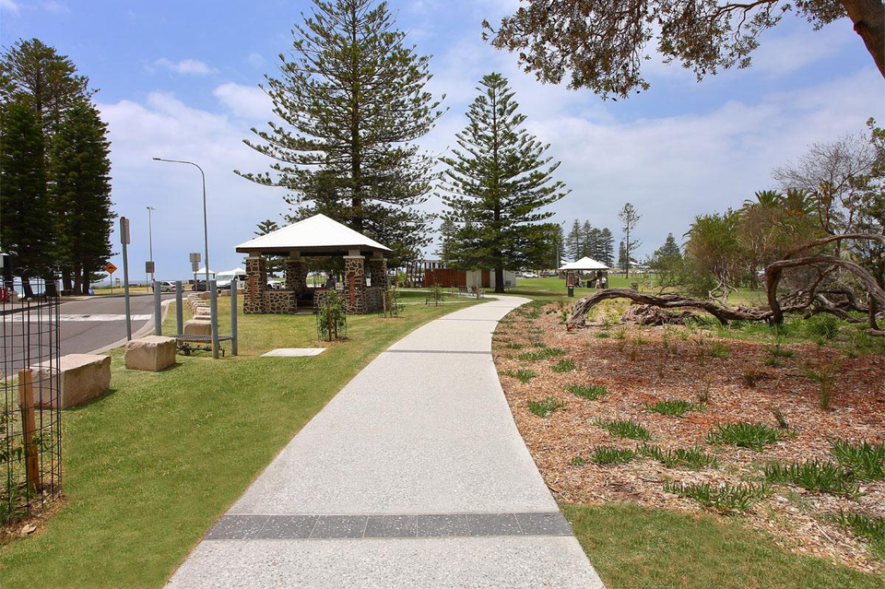 | People want better  - Footpaths  - Kerbs and ramps  - Signs
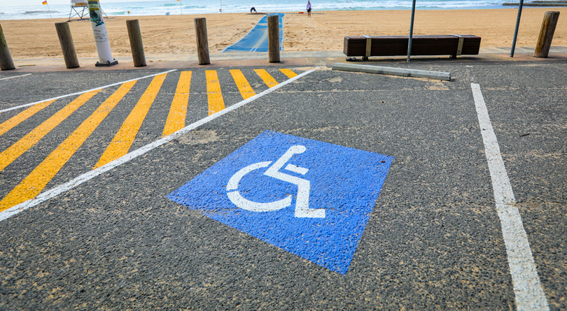 | They told us there is not enough  - Parking  - Accessible toilets  - Beach access
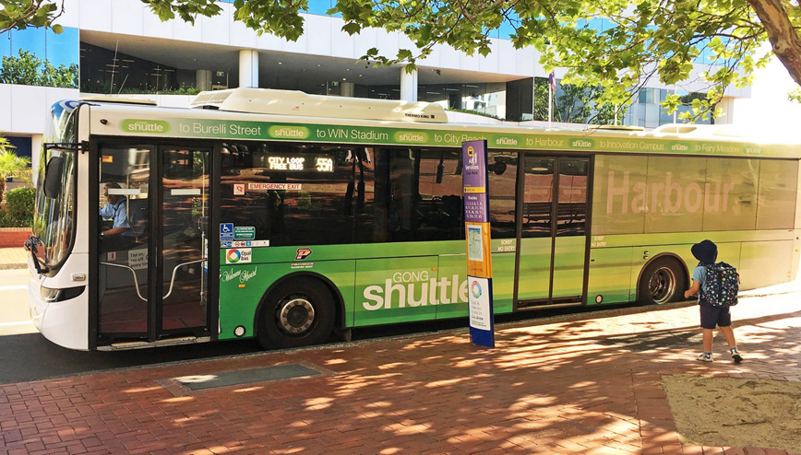 | People want better ways to get around  - Transport at night  - Shorter waiting times for taxis  - Improved bus services
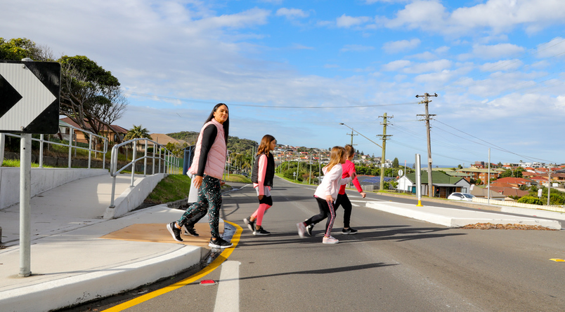 | People feel safer when there are  - Bright lights  - Safe places to cross the road
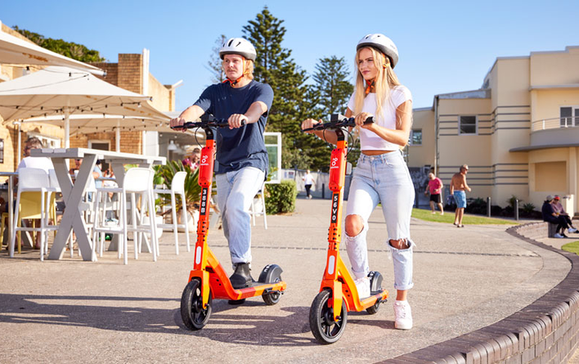 | E-bikes and scooters make some people feel unsafe on paths
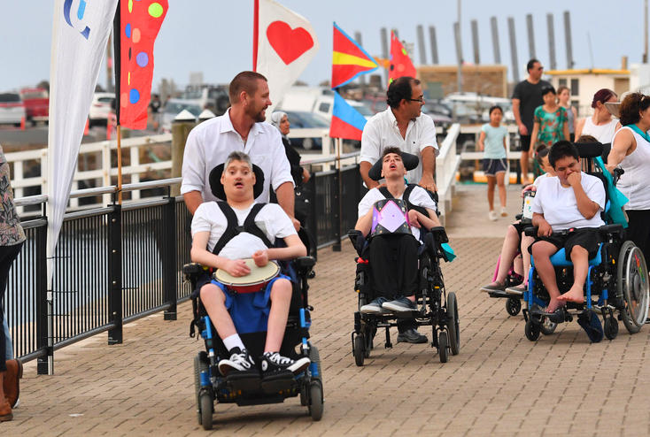 | People want to go to free events that include everyone
 | Carers told us they need help with  - Clear information about access  - Parking that is easy to find  - Safe places to drop people off
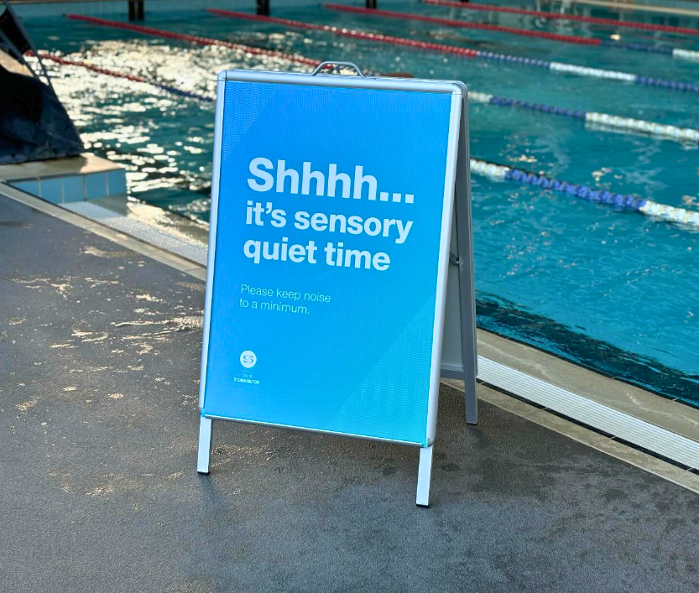 | Some people with sensory needs asked for  - Quiet spaces  - Soft lights  - Less noise
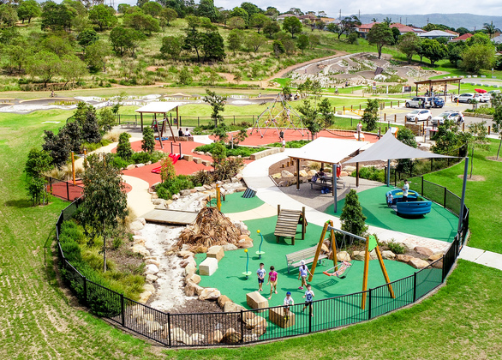 | Some people like playgrounds with  - Fences  - Seats in the shade
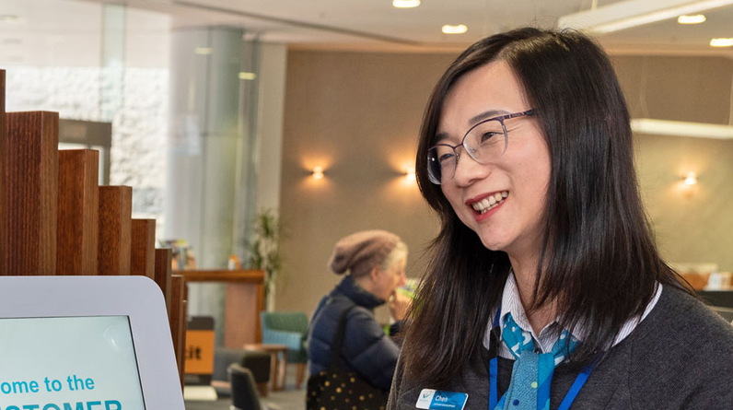 | People want Council staff to  - Understand disability  - Speak in a kind way
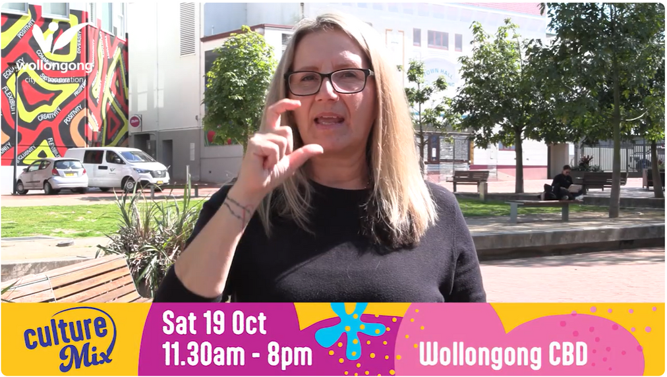 | People want to get information in different ways  - Easy Read and plain words  - Auslan videos  - Captions
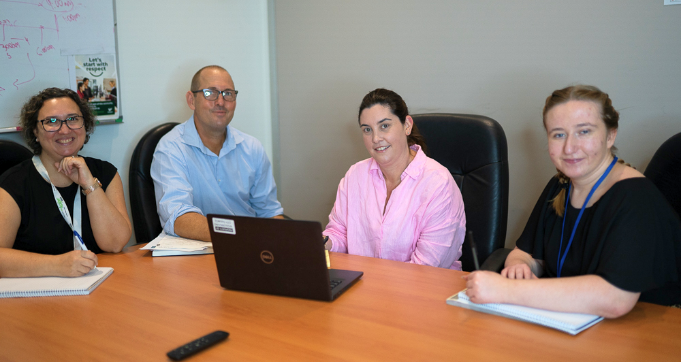 | People want fair chances to  - Get work  - Learn new skills in their job
 | People want to help Council make choices about things that matter to them
 | Council will use what people said to write the new plan
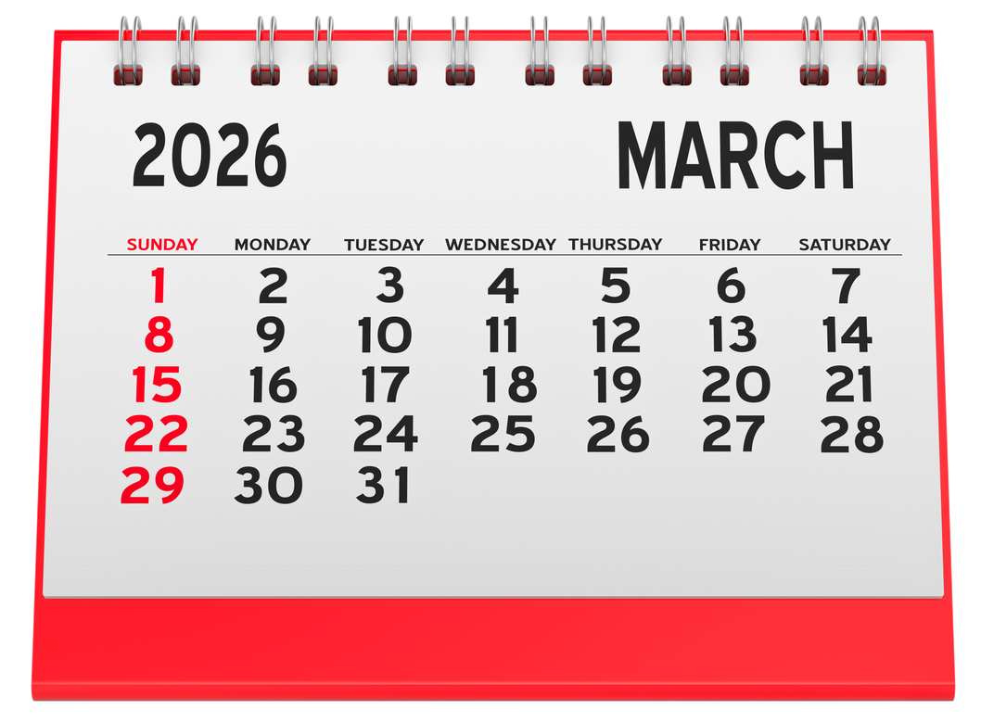 | A draft plan will be ready in early 2026
 | You can give feedback on the draft plan
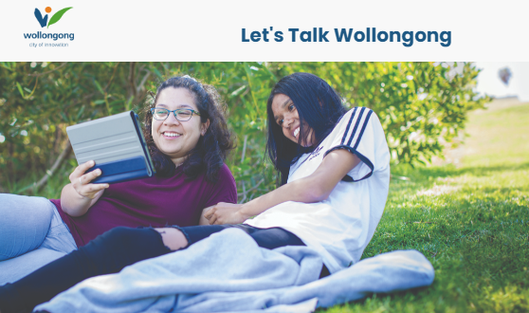 | Council will let everyone know when they can see the draft plan
 | Thank you to everyone who talked to us

